

KickSTArter campaigns analysis

Subhashree Mallick



December 12, 2020

Contents

1. Introductions 2

2. Conclusions 2

3. Limitations 4

4. Possible datasets and tables 4

5. Statistical Analysis 4

# Introductions

Over $2 billion has been raised using the massively successful crowdfunding service, Kickstarter, but not every project has found success. Of the more than 300,000 projects launched on Kickstarter, only a third have made it through the funding process with a positive outcome.

Getting funded on Kickstarter requires meeting or exceeding the project's initial goal, so many organizations spend months looking through past projects in an attempt to discover some trick for finding success.

# Conclusions

Based on the data collected in the spreadsheet following are my conclusions:

* Many successful funding happened during the summer months which is expected as people generally do outdoor activities during those months. The funding peaked during the months of May till July and receded to the lowest during the month of Dec.

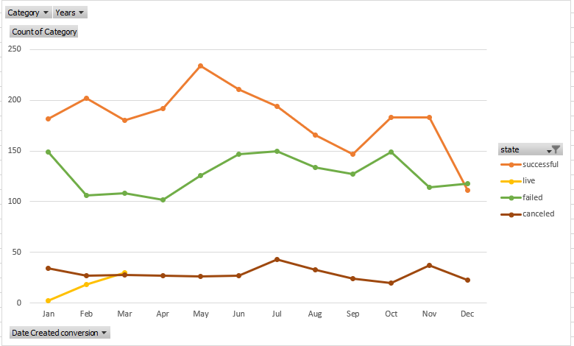

* As mentioned in the previous bullet point; music, film and theater are major contributor to the funding. The mentioned events are at the peak during the summer months. The number of events associated with Plays are higher compared to rest of the events. But if we compare plays with web then plays are roughly 69% successful whereas web events are 100%.

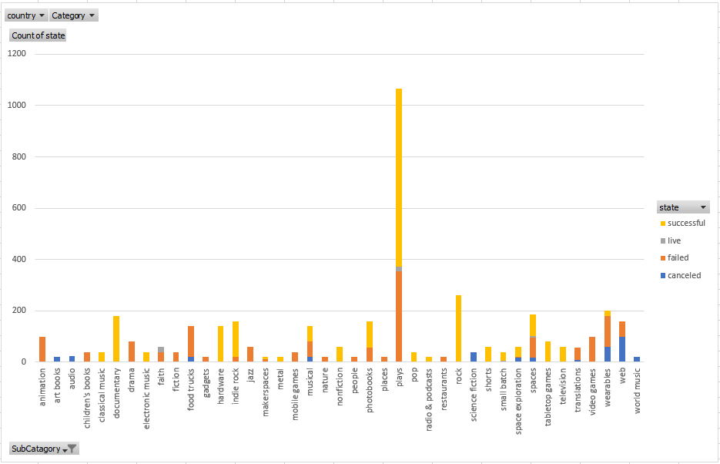

* Based on the event goals, it was eminent that higher the goal amount lesser the success rate. The success rate was 71% for goal amounts which are less than $1000. So, the event organizers should have increased the number of events keeping the goal within $1000.

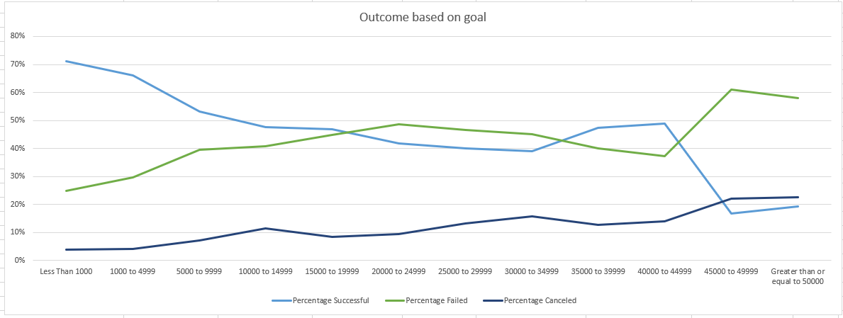

# Limitations

In accordance with me following are some of the limitations:

* There is no audience count category mentioned in the spreadsheet. Audience count would have provided a comprehensive view of the number of audiences versus the amount of funding.
* There’s no category which suggests age group of the audience which according to me is vital for fund raising events.

# Possible datasets and tables

Based on the data collected in the spreadsheet following are my observations of missing datasets and tables:

* There’s no available dataset which suggests the amount funded based on the categories, like theater, etc.

# Statistical Analysis

I have created a bonus tab in the spreadsheet providing statistical analysis of the funding events.

Based on the observation, it seems the variance is higher when the number of events are higher. In our case the mean for success is higher compared to mean for failed events which contributed to a higher range of variance.